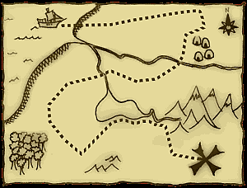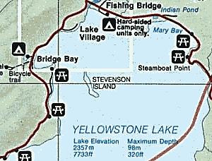

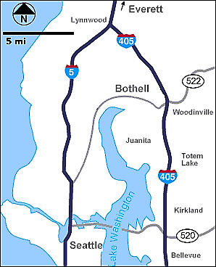

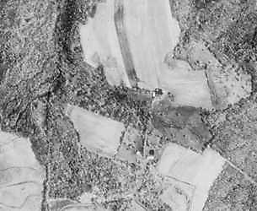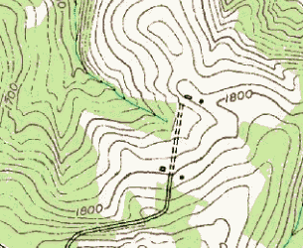

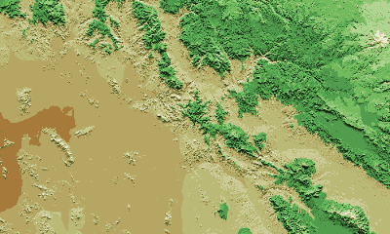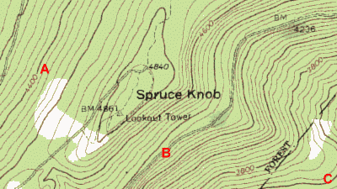

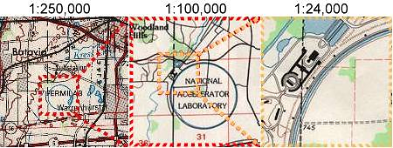

|  |  |
| --- | --- |
| Znaky na mapách  Doplň údaje k znakom na mapách /pomôž si s atlasom/ | |
|  | map symbol key |
|  | topographic map symbol |
|  | legend map symbol |
|  | map symbol |
|  | http://www.compassdude.com/i/maps/symbols/s019.gif |
|  | http://www.compassdude.com/i/maps/symbols/s053.gif |
|  | http://www.compassdude.com/i/maps/symbols/s054.gif |
|  | http://www.compassdude.com/i/maps/symbols/s055.gif |
|  | http://www.compassdude.com/i/maps/symbols/s056.gif |
|  | http://www.compassdude.com/i/maps/symbols/s057a.gif |
|  | http://www.compassdude.com/i/maps/symbols/s042a.gifhttp://www.compassdude.com/i/maps/symbols/s042b.gif |
|  | http://www.compassdude.com/i/maps/symbols/s043a.gifhttp://www.compassdude.com/i/maps/symbols/s043b.gif |
|  | http://www.compassdude.com/i/maps/symbols/s044a.gifhttp://www.compassdude.com/i/maps/symbols/s044b.gif |
|  | http://www.compassdude.com/i/maps/symbols/s045.gif |
|  | http://www.compassdude.com/i/maps/symbols/s046.gif |
|  | http://www.compassdude.com/i/maps/symbols/s047.gif |
|  | http://www.compassdude.com/i/maps/symbols/s048.gif |
|  | http://www.compassdude.com/i/maps/symbols/s049.gif |
|  | http://www.compassdude.com/i/maps/symbols/s050.gif |
|  | http://www.compassdude.com/i/maps/symbols/s051.gif |
|  | http://www.compassdude.com/i/maps/symbols/s052a.gifhttp://www.compassdude.com/i/maps/symbols/s052b.gif |
|  | http://www.compassdude.com/i/maps/symbols/s058.gif |
|  | http://www.compassdude.com/i/maps/symbols/s059.gif |
| **Budovy** | |
|  | http://www.compassdude.com/i/maps/symbols/s100a.gifhttp://www.compassdude.com/i/maps/symbols/s100b.gif |
|  | http://www.compassdude.com/i/maps/symbols/s101.gif |
|  | http://www.compassdude.com/i/maps/symbols/s102a.gifhttp://www.compassdude.com/i/maps/symbols/s102b.gif |
|  | http://www.compassdude.com/i/maps/symbols/s103a.gifhttp://www.compassdude.com/i/maps/symbols/s103b.gif |
|  | http://www.compassdude.com/i/maps/symbols/s104a.gifhttp://www.compassdude.com/i/maps/symbols/s104b.gif |
|  | http://www.compassdude.com/i/maps/symbols/s105.gif |
|  | http://www.compassdude.com/i/maps/symbols/s106.gif |
|  | http://www.compassdude.com/i/maps/symbols/s107a.gifhttp://www.compassdude.com/i/maps/symbols/s107b.gif |
|  | http://www.compassdude.com/i/maps/symbols/s108.gif |
|  | http://www.compassdude.com/i/maps/symbols/s109.gif |
|  | http://www.compassdude.com/i/maps/symbols/s110.gif |
|  | http://www.compassdude.com/i/maps/symbols/s111.gif |
| **Komunikácie** | |
|  | http://www.compassdude.com/i/maps/symbols/s113.gif |
|  | http://www.compassdude.com/i/maps/symbols/s114.gif |
|  | http://www.compassdude.com/i/maps/symbols/s115a.gifhttp://www.compassdude.com/i/maps/symbols/s115b.gif |
|  | http://www.compassdude.com/i/maps/symbols/s116a.gifhttp://www.compassdude.com/i/maps/symbols/s116b.gif |
|  | http://www.compassdude.com/i/maps/symbols/s117.gif |
|  | http://www.compassdude.com/i/maps/symbols/s118a.gifhttp://www.compassdude.com/i/maps/symbols/s118b.gif |
|  | http://www.compassdude.com/i/maps/symbols/s119a.gifhttp://www.compassdude.com/i/maps/symbols/s119b.gif |
|  | http://www.compassdude.com/i/maps/symbols/s120a.gifhttp://www.compassdude.com/i/maps/symbols/s120b.gif |
|  | http://www.compassdude.com/i/maps/symbols/s121a.gifhttp://www.compassdude.com/i/maps/symbols/s121b.gif |
|  | http://www.compassdude.com/i/maps/symbols/s122a.gifhttp://www.compassdude.com/i/maps/symbols/s122b.gif |
|  | http://www.compassdude.com/i/maps/symbols/s123a.gifhttp://www.compassdude.com/i/maps/symbols/s123b.gif |
|  | http://www.compassdude.com/i/maps/symbols/s124a.gifhttp://www.compassdude.com/i/maps/symbols/s124b.gif |
|  | http://www.compassdude.com/i/maps/symbols/s125.gif |
|  | http://www.compassdude.com/i/maps/symbols/s126.gif |
|  | http://www.compassdude.com/i/maps/symbols/s127.gif |
|  | http://www.compassdude.com/i/maps/symbols/s129.gif |
|  | http://www.compassdude.com/i/maps/symbols/s130.gif |
|  | http://www.compassdude.com/i/maps/symbols/s131a.gifhttp://www.compassdude.com/i/maps/symbols/s131b.gif |
|  | http://www.compassdude.com/i/maps/symbols/s132.gif |
|  | http://www.compassdude.com/i/maps/symbols/s133.gif |
| **Hranice** | |
|  | http://www.compassdude.com/i/maps/symbols/s025.gif |
|  | http://www.compassdude.com/i/maps/symbols/s026.gif |
|  | http://www.compassdude.com/i/maps/symbols/s027.gif |
|  | http://www.compassdude.com/i/maps/symbols/s028.gif |
|  | http://www.compassdude.com/i/maps/symbols/s030a.gif |
|  | http://www.compassdude.com/i/maps/symbols/s031.gif |
| Rieky, jazerá, kanály | |
|  | http://www.compassdude.com/i/maps/symbols/s076a.gifhttp://www.compassdude.com/i/maps/symbols/s076b.gif |
|  | http://www.compassdude.com/i/maps/symbols/s077a.gifhttp://www.compassdude.com/i/maps/symbols/s077b.gif |
|  | http://www.compassdude.com/i/maps/symbols/s078.gif |
|  | http://www.compassdude.com/i/maps/symbols/s079.gif |
|  | http://www.compassdude.com/i/maps/symbols/s080.gif |
|  | http://www.compassdude.com/i/maps/symbols/s081.gif |
|  | http://www.compassdude.com/i/maps/symbols/s082.gif |
|  | http://www.compassdude.com/i/maps/symbols/s083.gif |
|  | http://www.compassdude.com/i/maps/symbols/s084.gif |
|  | http://www.compassdude.com/i/maps/symbols/s085a.gifhttp://www.compassdude.com/i/maps/symbols/s085b.gif |
|  | http://www.compassdude.com/i/maps/symbols/s086a.gifhttp://www.compassdude.com/i/maps/symbols/s086c.gif |
|  | http://www.compassdude.com/i/maps/symbols/s087a.gifhttp://www.compassdude.com/i/maps/symbols/s087b.gif |
|  | http://www.compassdude.com/i/maps/symbols/s088a.gifhttp://www.compassdude.com/i/maps/symbols/s088b.gif |
|  | http://www.compassdude.com/i/maps/symbols/s090.gif |
|  | http://www.compassdude.com/i/maps/symbols/s091.gif |
|  | http://www.compassdude.com/i/maps/symbols/s092.gif |
|  | http://www.compassdude.com/i/maps/symbols/s093.gif |
|  | http://www.compassdude.com/i/maps/symbols/s094.gif |
|  | http://www.compassdude.com/i/maps/symbols/s095.gif |
|  | http://www.compassdude.com/i/maps/symbols/s096.gif |
|  | http://www.compassdude.com/i/maps/symbols/s097.gif |
|  |  |